**Graded Assignment 4 – Spring RESTful API with H2 and Postman**

**Student Management Project:**

**Package Structure and Class Structure:**

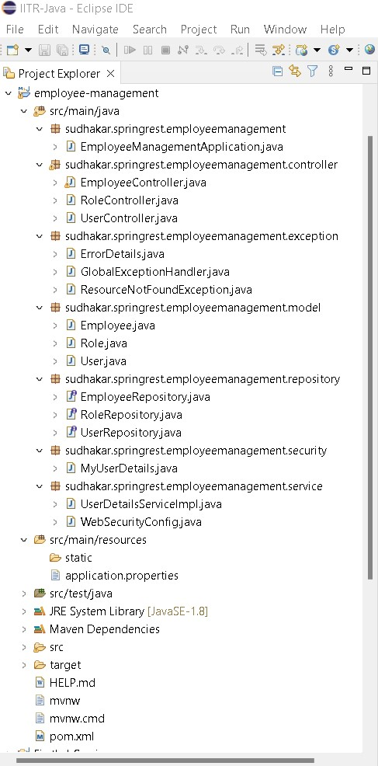

**Screenshots:**

**Initial Get: (empty database)**

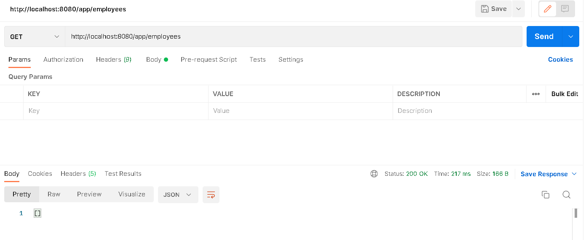

**Post:**

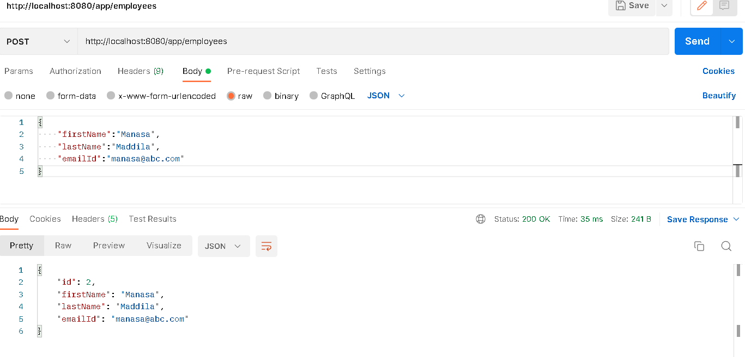

**GET:**

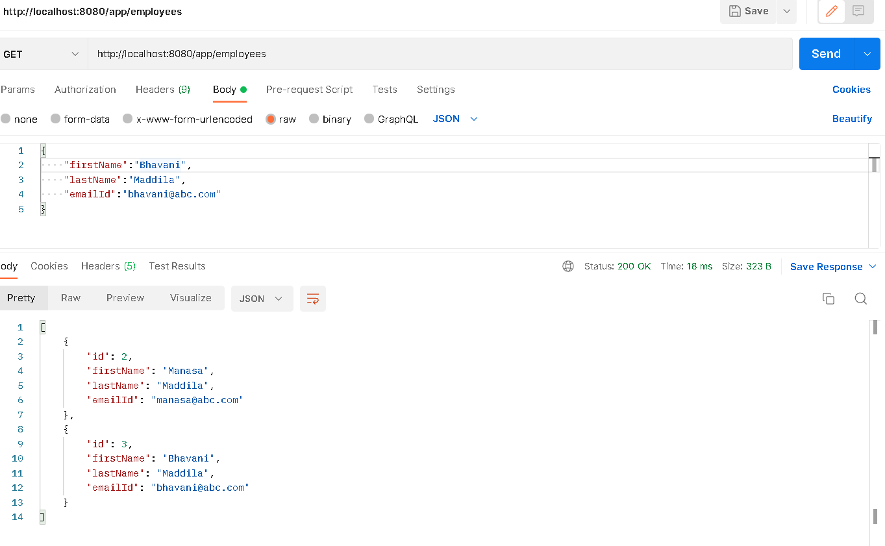

**PUT:**

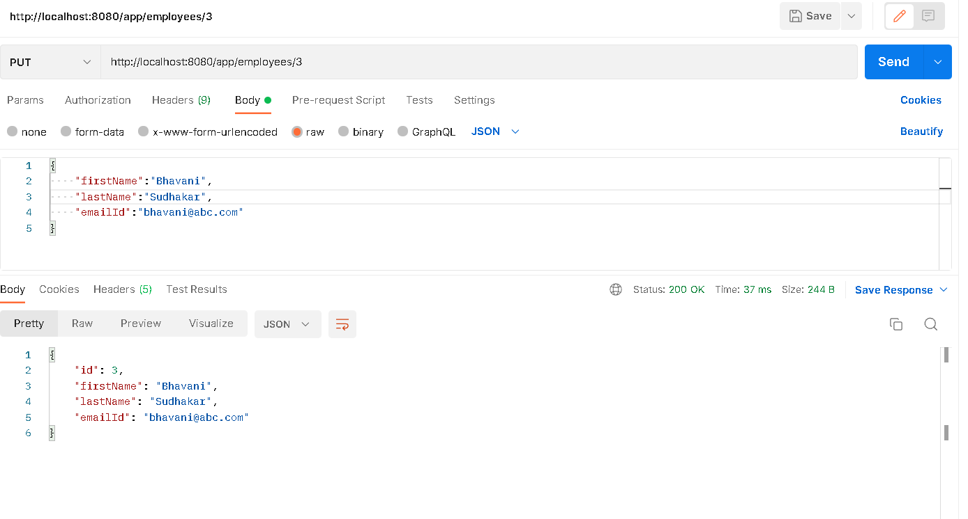

**DELETE with not found:**

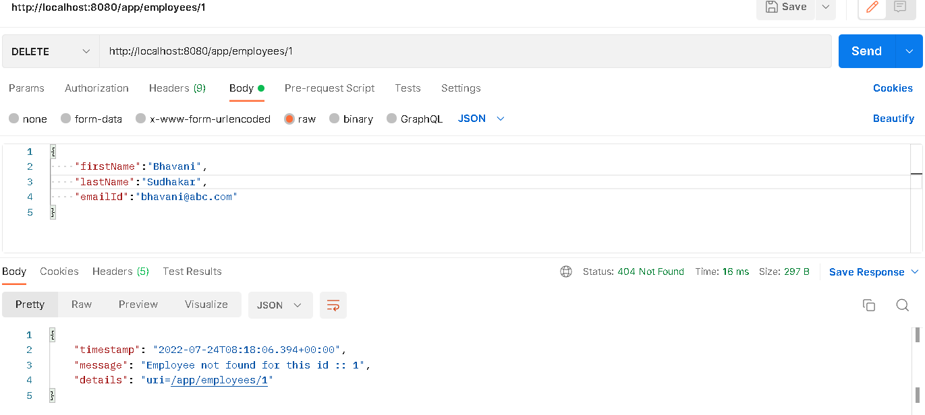

**DELETE:**

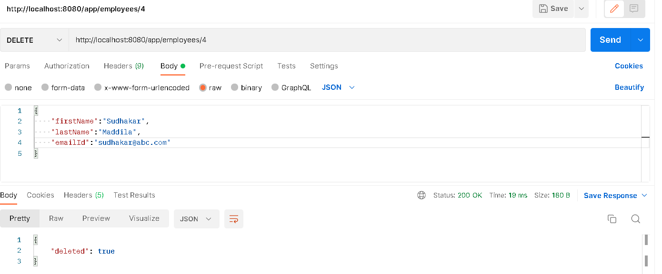

**USERS database:**

**Empty Users Database at beginning**

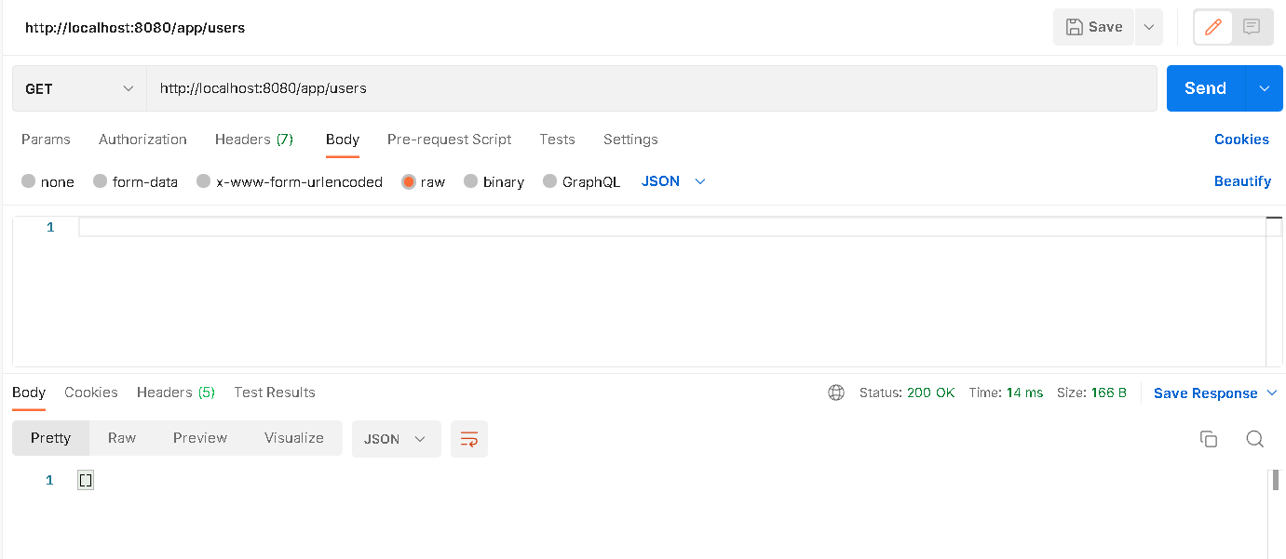

**POST on USERS**

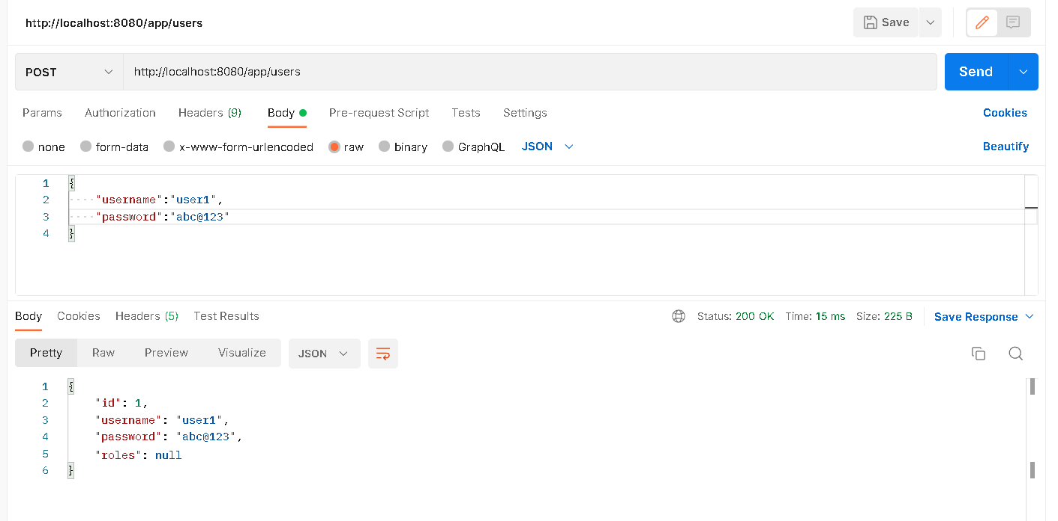

**GET on USERS**

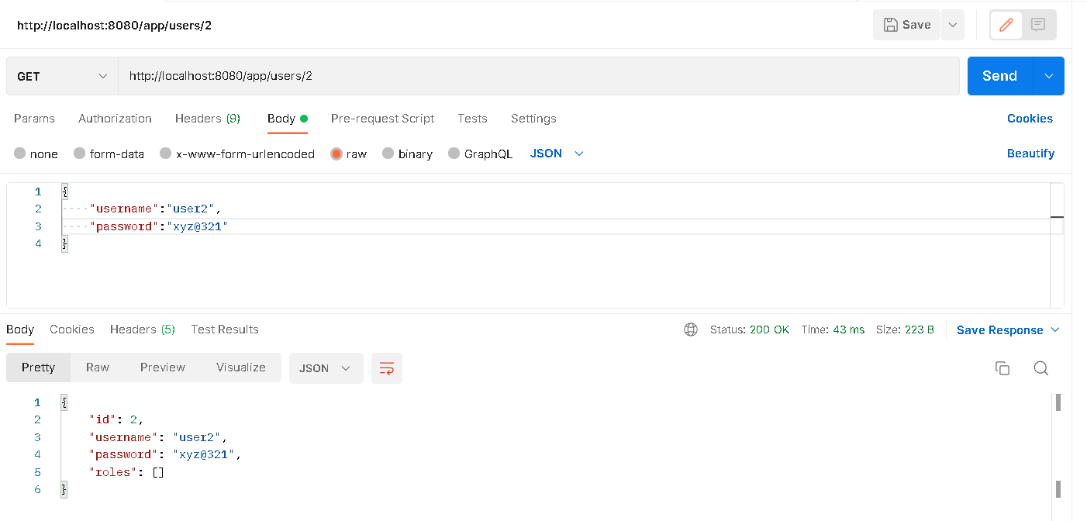

**DELETE on Users**

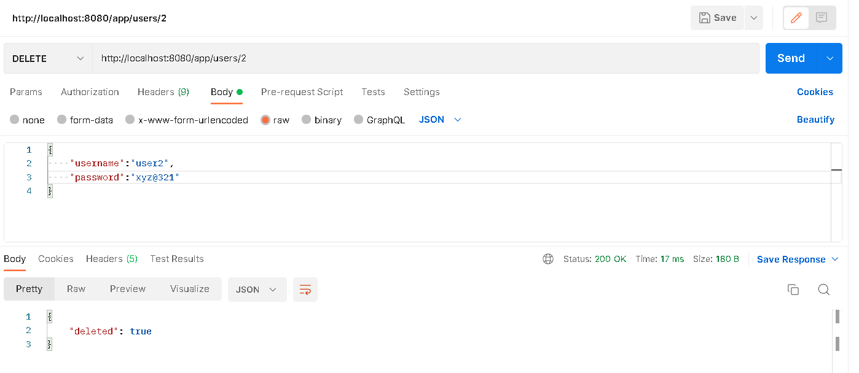

**POST on ROLES**

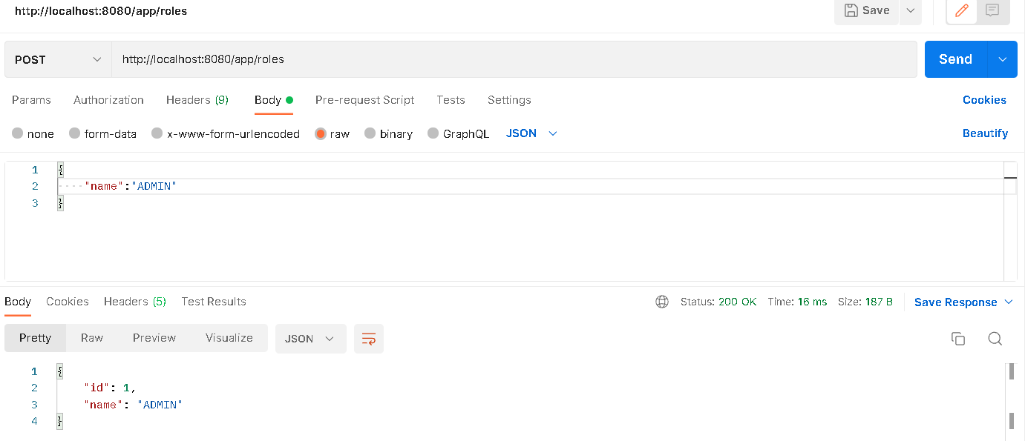

**GET on ROLES**

